HANDS FREE CART

MGT1027 PRODUCT DESIGN, MANAGEMENT TECHNIQUES AND ENTREPRENEURSHIP

Report submitted in partial fulfilment of the requirements for the degree of

Integrated MTech in CSE specialization with Business Analytics

by
Magna(22MIA1004)
Anusha (22MIA1111)
Lohitha (22MIA1152)
Vidhya Sree (22MIA1089)
Vasundhara (22MIA1199)
Yuvalakshmi (22MIA1040)
under the guidance of
DR. MEKHALA R S

VIT BUSINESS SCHOOL (VITBS)



November 2023

BONAFIDE CERTIFICATE

This is to certify that this project entitled “HAND FREE CART” submitted in partial fulfilment of the degree of Bachelor of Technology to Vellore Institute of Technology, Chennai, done by Ms. Yuvalakshmi Register No. 22MIA1040, Ms. Magna Register No.22MIA1004, Ms. Anusha Register No. 22MIA1111, Ms. Lohitha Register No. 22MIA1152, Ms. Vidhya Sree Register No.22MIA1089, and Ms. Vasundhara Register No. 22MIA1199 are an authentic work carried out by under my guidance. The matter embodied in this project work has not been submitted earlier for award of any degree or diploma to the best of my knowledge and belief.

Place: VIT Chennai
Date:

Signature of the Course Faculty

The report is satisfactory / unsatisfactory

Signature of the Internal Examiner Signature of the External Examiner

Approved by

Head of the Department

DECLARATION

We Yuvalakshmi, Magna, Anusha, Lohitha, Vidhya Sree, Vasundhara bearing Reg. No. 22MIA1040, 22MIA1004, 22MIA1111, 22MIA1152, 22MIA1089 and 22MIA1199 respectively hereby declare that this project report entitled HAND FREE CART has been prepared towards the partial fulfilment of the requirement of the course Product Design, Management Techniques and Entrepreneurship under the guidance of DR. MEKHALA R S. I also declare that this project report is my original work and has not been previously submitted for the award of any Degree, Diploma, Fellowship, or other similar titles.

Place: VIT Chennai

Date:

ABSTRACT

The goal of this research project is to create a workable and usable travel cart that can follow its user in crowded spaces like malls, shopping centres and transportation hubs. The provision of usability and accessibility is the main priority, especially for those who have mobility issues, such as elderly people, people with disabilities, patients, children, etc. The project involves creating a cutting-edge cart with cutting-edge control and navigational technology. To address particular customer needs, this involves combining engineering, technology, and user-centered design. These needs include being easily accessible, affordable, having the ability to support heavy loads, operating smoothly, and having an emergency safety system.
This project's main objective is to build a user-friendly and self-driving travel cart that has the potential to greatly improve mobility and independence for a variety of users in busy public areas. Future efforts will focus on optimising the design, running user testing, and solving technological issues. With this invention, everyone could benefit from more convenient and inclusive public transit.
Keywords: User-Centered Design, Mobility, Autonomous Navigation, Technology, Inclusivity, Public Spaces, Autonomous Travel Cart.

ACKNOWLEDGEMNT

We are using this opportunity to express our gratitude to everyone who supported us throughout the course of this project. We are thankful for their aspiring guidance, invaluably constructive criticism and friendly advice during the project work. We are sincerely grateful to them for sharing their truthful and illuminating views on a number of issues related to the project.

We wish to place on record the profound gratitude to our guide, Dr. Mekhala R S, VIT Business School (VITBS), Vellore Institute of Technology, Chennai for her constant encouragement, continued support, and valuable guidance without which this work could not have been possible. The support and encouragement given by our friends and colleagues are beyond words and we are deeply indebted to her for her continued help and dedication.

TABLE OF CONTENTS

S.NO. | TITLE | PAGE NO.
1. | Introduction | 7
2. | Problem Statement | 8
3. | Objective and scope | 9
4. | Literature review | 10
5. | Chapter 1: Product Prototype
6. | Chapter 2: Product Development and Market Research
7. | Chapter 3: Product Economic Feasibility - Strategies with Tools and Budget
8. | Chapter 4: Entrepreneurial Competence
9. | Conclusion
10. | Bibliography

INTRODUCTION

Convenience is a highly valued commodity in today's fast-paced world, as technology is constantly changing how we navigate and interact with our surroundings. Over time, the shopping experience has seen significant innovation and evolution, making it a vital component of our lives. One of the newest inventions that has the potential to completely change the shopping experience is the hands-free shopping cart, an innovative idea that will improve everyday routines and make shopping more effective and convenient than it has ever been.

The idea of a hands-free shopping cart signifies a big advancement in our method of approaching the tiresome chore of hauling items and supermarket shopping. It is a representation of the marriage of state-of-the-art technology with our changing way of life, meeting the demands of a varied and vibrant customer base. The hands-free shopping cart is going to be a lifesaver for a wide range of people in this age of multitasking and always being on the go, from parents and working professionals to senior citizens and those with impairments.

The fascinating voyage into the world of the hands-free shopping cart begins with this introduction. We shall explore this novel idea's technology, design principles, advantages, and possible uses in the pages that follow. Come learn how the blending of technology and daily life will transform how we purchase, making it more convenient, pleasurable, and open to all. Welcome to the future of shopping, where options are endless, and convenience is king.

PROBLEM STATEMENT

Transporting baggage, purses, and other items can be an arduous and exhausting undertaking in crowded public spaces such as bus terminals, train stations, airports, and shopping centers. This is especially true for a number of groups, including the elderly, those with disabilities, people who are ill, and visitors who are carrying a lot of luggage. Even though they are common, current carts usually don't match consumers' evolving needs in terms of usability, accessibility, and technological innovation.

The main issue at hand is the pressing requirement for a revolutionary solution that totally alters the way we carry our goods in public spaces in a way that is not only useful and simple to use, but also enhances the travel experience overall. Despite having wheels for easy transportation, typical carts are not extremely inexpensive, controlled, or user-friendly. These carts usually lack the modern comforts that have become standard in today's lives, such as anti-theft systems, smart features, GPS monitoring, and obstacle avoidance.

Therefore, the goal of this project is to be the pioneer in the creation of an innovative and cutting-edge "Hands-Free Cart." This self-driving cart will follow its users through crowded public spaces thanks to its easy-to-use and intuitive design, saving them the trouble of carrying their belongings and baggage. The Hands-Free Cart is made to be the ultimate in user convenience, featuring a big storage capacity, many easy controls, powerful obstacle avoidance algorithms, integrated GPS monitoring for location awareness, and robust anti-theft features.

In essence, the Hands-Free Cart project seeks to revolutionize the way we use and engage with luggage carts, ensuring that they satisfy the needs of modern travellers, surpass traditional limitations, and provide a comprehensive and state-of-the-art solution to make travel safer, easier, and much more pleasurable for everyone.

OBJECTIVE AND SCOPE

The goal of the "Hands-Free Cart" initiative is to change how people carry their baggage around public spaces including transit hubs, malls, and airports. The elderly, disabled, and visitors are among the users of these areas. The primary objective is to provide a user-centric solution that offers a seamless and simple experience. This means creating an autonomous cart to lessen the physical strain of pushing or lugging heavy goods by hand. To do this, it is crucial to incorporate smart features like GPS tracking, obstacle avoidance, and anti-theft mechanisms that enhance the cart's overall functionality, security, and user-friendliness.

In addition to its technological capabilities and self-sufficient operation, the "Hands-Free Cart" project includes the construction of a spacious storage area. a location that meets its clients' practical storage needs. To ensure that the device is as user-friendly as possible, the project plans to include controls and interfaces that allow users to modify the behavior of the cart and readily interact with it. Making the Hands-Free Cart an affordable solution that can be used by a variety of customers while satisfying a range of budgetary needs is another crucial objective. Production, quality assurance, and distribution planning are also included in the project to ensure that the cart is prepared for customer use before to its introduction onto the market. Extensive testing is necessary to guarantee that the cart's autonomous operation, obstacle avoidance, and anti-theft features perform without fail because safety and dependability are of the utmost significance.

The project will investigate ways to protect the environment by including eco-friendly materials and energy-efficient components wherever it is practical, in line with current sustainability trends. The project also acknowledges the need for continuous improvement, taking user input and emerging technologies into consideration, to enhance the Hands-Free Cart and maintain its competitiveness in the market.

LITRATURE REVIEW

1.Automated Luggage Handling in Public Spaces:

Several studies have investigated the difficulties that people—older adults, individuals with impairments, and tourists carrying large amounts of luggage—experience when attempting to push traditional carts through crowded public areas like airports and retail malls. The literature now in publication emphasizes the necessity of creative fixes to enhance accessibility and user experience.

2.Autonomous Robotic Systems:

An increasing amount of study is being done in the fields of robotics and automation on the creation of autonomous robots that can help in carrying and moving objects. These robots travel and interact with their surroundings by using sophisticated control systems and sensors.

3. Smart Carts and Luggage Solutions:

There's a trend in the travel and baggage business toward smart luggage solutions with capabilities like self-propulsion, remote locking, and GPS monitoring. These goods are meant to improve the efficiency and convenience of travel.

4. Obstacle Avoidance and Navigation:

To successfully construct a hands-free cart, research on obstacle avoidance and navigation in autonomous systems is necessary. For this, several sensor technologies have been investigated, including infrared and ultrasonic sensors. These sensors allow for dynamic route planning and obstacle identification in real time.

5. Materials and Durability:

A crucial component of product design is choosing the right materials. The use of materials like ABS and polycarbonate for the chassis and frames of autonomous systems is discussed in the literature, with an emphasis on strength and durability while maintaining a tolerable weight.

6. Technologies related to Power Management and Batteries:

Effective power management and the deployment of appropriate battery technologies are critical to the uninterrupted operation of autonomous systems. Batteries made on lithium iron phosphate (LiFePO4) are renowned for their excellent energy density and security features.
7.Wristwatch Integration and Smart Features:

Using wristwatches to integrate smart features into autonomous systems is becoming more and more common. Research highlights the significance of intuitive user interfaces and real-time tracking, which essentially turn the device into an active user companion.

8. Safety and Theft Prevention Mechanisms:

One of the main concerns with autonomous systems is safety. According to research, safety elements that protect the hands-free cart and its items inside from theft include locking mechanisms and anti-theft procedures.

9. Aesthetics and Design:

The acceptance of autonomous systems is influenced by aesthetics. Various colours, coatings, and design features have been investigated in research to improve the attractiveness of these products.

10.Benchmarking and evaluation:

As specified in our proposal, studies have used benchmarking matrices and evaluation criteria to choose the most promising design concept for additional development.

CHAPTER 1: PRODUCT PROTOTYPE

CONCEPT GENERATION

Customer requirements:
- Easy-to-access carts
- Being able to use the cart for travel efficiently
- Obtainable at an affordable price
- Providing control over the cart
- Space available for keeping the luggage in a cart
- Ready to use in the market
- Ability to lift heavy weights
- Smooth course of action
- Directive
- Secure area for luggage and things
- Alternate method of handling the cart in case of emergency

Problem statement
To develop a cart capable of manoeuvring through busy airports, supermarkets, railways and malls behind its owner while hauling their luggage. To follow a human, the product needs to know the person's position and must be able to determine its path to pursue its target and carry its luggage. The objective is to design a travelling cart that is easily accessible, spacious and user-friendly with anti-theft and anti-crashing mechanisms.

Gathering information:
Cart:
Carts are provided in airports, shopping malls, bus stations, hotels or train stations nowadays for transporting luggage.
Functions:
  - Transporting luggage
  - Shopping purpose
  - Carry bags

Hand free suitcase:
These suitcases provide the essential relief we seek; nothing compares to these self-moving luggage pieces.
Functions:
  - GPS tracking
  - Self-propulsion
  - Remote locking
  - Allowing you to move it without touching

Hand free cart:
The hands-free cart works on Bluetooth technology interfaced with a controlling unit GPS/GSM module, RFID cards, ultrasonic sensors, power unit, load cell, metal basket, handle, and wheels. Follows the user using a sensor and helps them carry a specified amount of weight without holding the cart.

Functions:
  - Carry luggage
  - Used as a cart which is free from heavy holding bags
  - Push and move it in any vehicle
  - Easy access
  - Affordable control

Concept generation:
Brainstorming:
After identifying the problem, we tried combining the existing automatic suitcase with the carts available in the market to produce a new product, namely HANDS-FREE CART.
We found no such product in the market to compete; therefore, applying for a patent can also be done with our development. We tried coming up with a mind map for this concept.

MIND MAP:
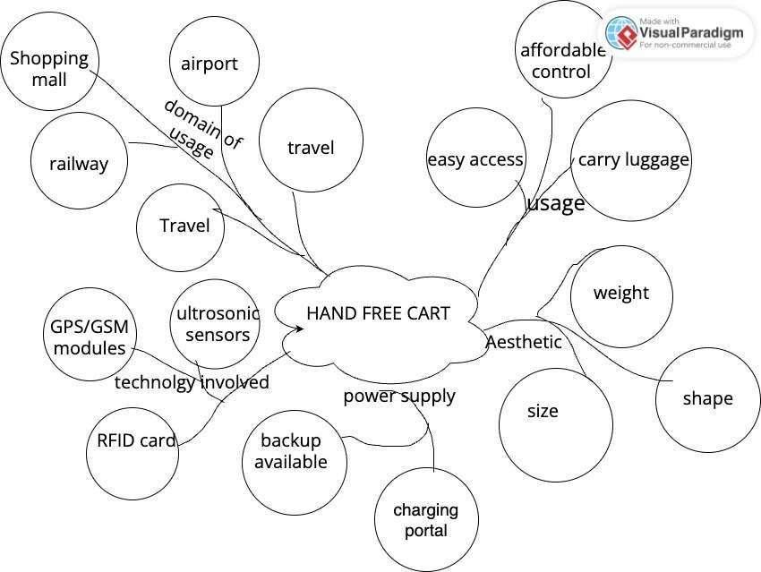

SCAMPER:
Using the concepts which are involved in SCAMPER, we developed a new product. For instance,
Combine- combined the idea of a free suitcase with the cart and made a hand-free cart. Modify-we modified the existing cart design with a new idea.
Eliminate- we eliminated the handle and child seat to provide extra space for the carriage

TRIZ:
We implemented the principles of TRIZ to develop our concepts Some of the concepts are:

Combining:
Combining cart with hand free suitcase

Problems analysis:
We analysed the general and specific problems with public and particular solutions, respectively.
Thus, TRIZ helped to improve the project with enhanced specifications.

SELECTION MATRIX

PRODUCT CONCEPTS:
We developed four new products with the customer problems. After concept generation, we tried developing different designs for our product.
Concept 1:
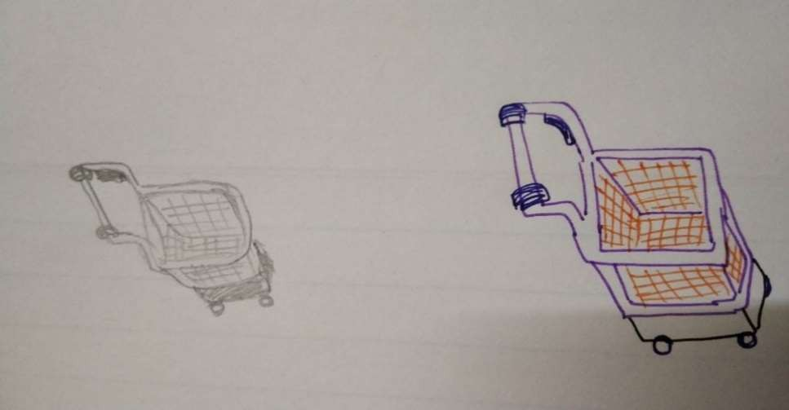
Concept 2:
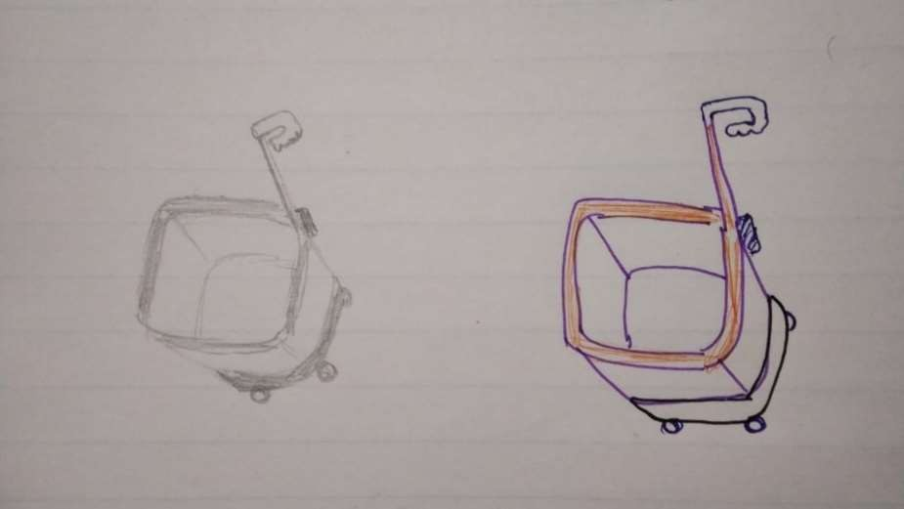
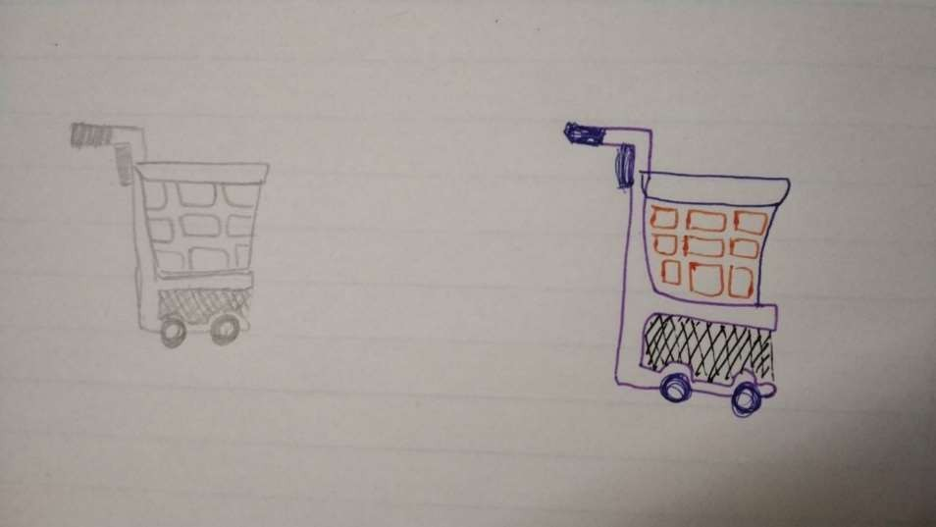
Concept 3:

Concept 4:
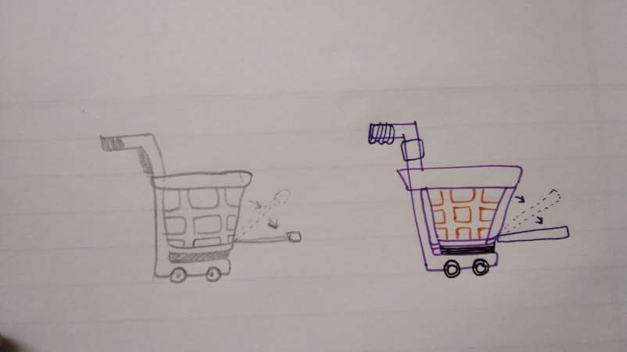
Utilizing the principles of TRIZ and SCAMPER, we devised four innovative concepts for our hands-free cart product. To identify the most promising concept for further refinement, a thorough evaluation was necessary. Employing the Benchmarking matrix approach, we scrutinized the designs across the criteria specified below.

Parameters | Concept 1 | Concept 2 | Concept 3 | Concept 4
Durability | 8 | 7 | 8 | 8
Storage Capacity | 5 | 9 | 8 | 8
Maneuverability | 6 | 7 | 7 | 8
Security | 7 | 7 | 7 | 9
Eco-Friendly | 5 | 6 | 5 | 5
Cost | 7 | 7 | 8 | 9
Weight | 8 | 8 | 9 | 7
Portability | 7 | 6 | 8 | 9
Load Capacity | 6 | 9 | 7 | 8
Ease of use | 7 | 7 | 8 | 9
Total | 66 | 73 | 75 | 80

Concept 4 is comparatively superior according to the benchmarking matrix by considering the comparison parameters. Consequently, we go for the progression of Concept 4 in the development process

SKETCHES/PROTOTYPE
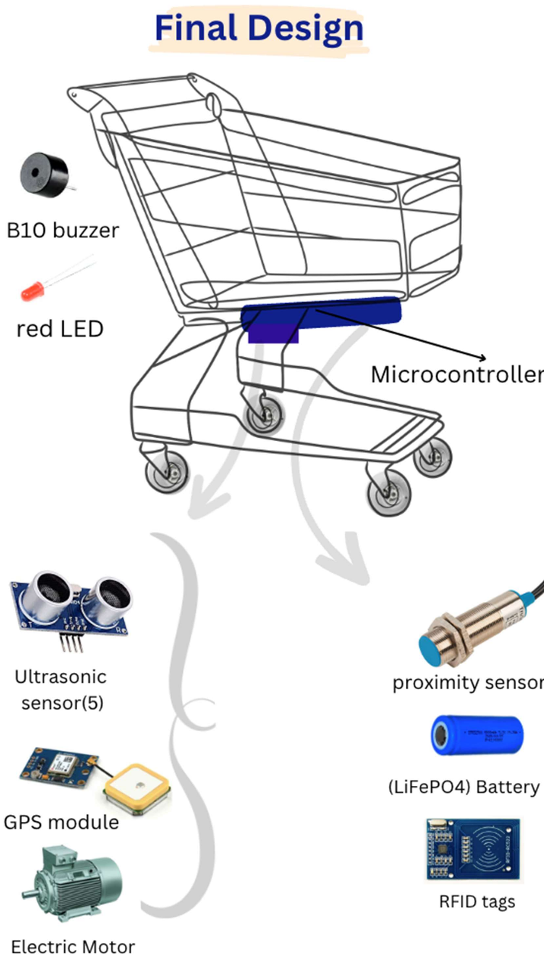

PRODUCT SPECIFICATION
MATERIAL SELCTION:
Chassis and Frame:
Material: Plastic- Acrylonitrile Butadiene Styrene (ABS), Polycarbonate
Features: Provides strength and durability while keeping the overall weight of the cart manageable. Resistant to corrosion, ensuring longevity.

Wheels and Suspension:
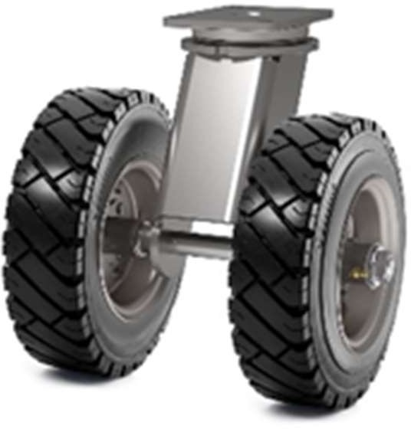
Material: 10-inch diameter polyurethane tires
Features: Exceptional durability, High traction, Noise reduction.
Polyurethane construction provides superior resistance to wear, abrasion, and weather, ensuring extended lifespan and consistent performance. Tires offer excellent grip on various surfaces, enhancing stability and manoeuvrability for the cart. The shock-absorbing properties of polyurethane minimize vibrations and noise, contributing to a smoother and quieter cart operation.

Motor and Drivetrain:
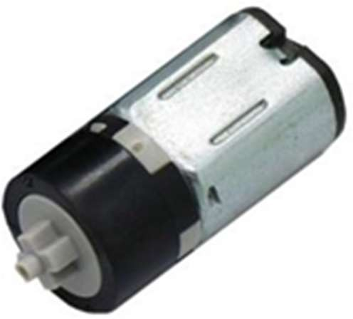
Material: DC motor - High-torque 100 RPM 12V with gearbox and 6mm shaft, optimized for efficient conversion of electrical energy to mechanical motion
Features:
Precise Speed Control, High Torque, Weight and Size Efficiency. The motor's speed is adjustable via voltage or current manipulation, enabling fine-tuned control for various
applications. Capable of delivering 1.5 Kg/cm stall torque, ensuring robust movement and performance even under load. Compact design with a 6mm shaft diameter and internal hole, weighing 125 gm, making it suitable for applications requiring space-saving solutions

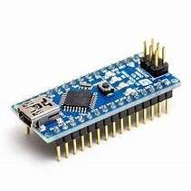
Control Unit and Electronics:

Arduino Nano
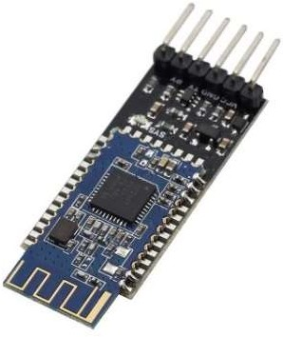
Hc-10 blue-tooth module with 8051 core
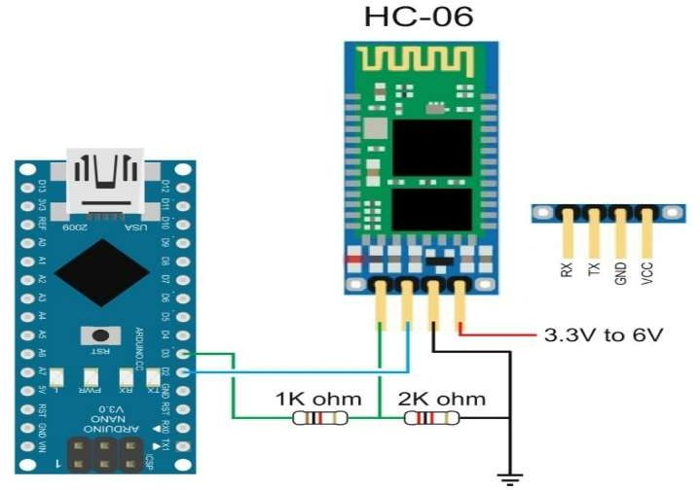
Arduino and HC-06(ZS040) Material: Hc-10 blue-tooth module with 8051 core.
Features: The HC-06 Bluetooth module facilitates wireless control of an Arduino project through smartphone or tablet communication, enabling command transmission for project manipulation. Real-time location data from the GPS module allows for movement tracking and location-triggered actions. Sensor integration, including temperature, proximity, and light sensors, enables environment-responsive behaviors.
Incorporating DC motors offers movement possibilities, from GPS-guided robotics to remote-controlled vehicles. The system logs sensor and GPS data and supports customizable Bluetooth commands, remote monitoring, and potential integration with mapping services. Such projects serve educational purposes, fostering electronics, programming, and sensor integration skills while providing a platform for prototyping and concept testing on a smaller scale. Careful planning, power consideration, and effective data communication management are critical to a functional and successful system.

Sensors:

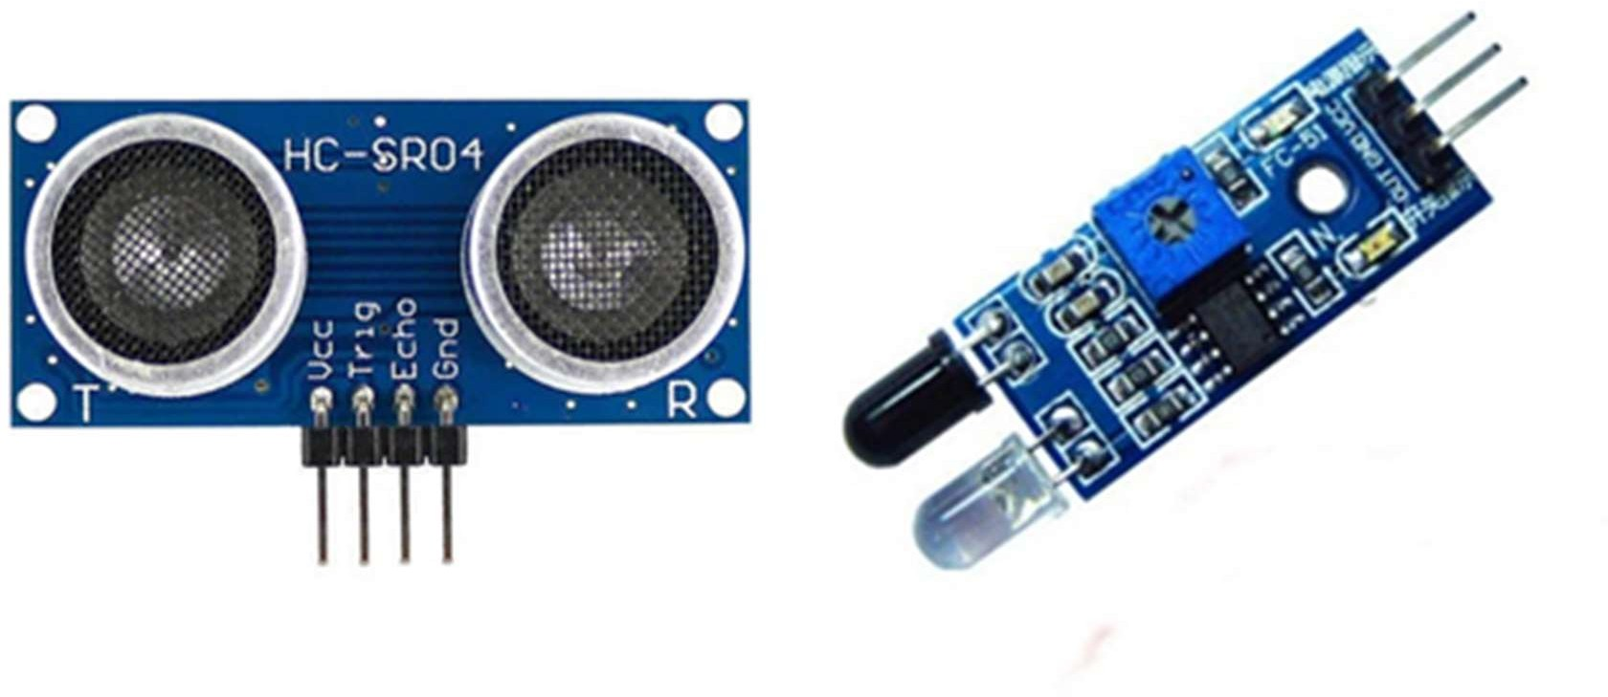
Ultrasonic sensor IR sensor
Material: Ultrasonic sensor (Target Detection), dimensions of approximately 3 cm x 3 cm x 1.5 cm.
IR sensor (Obstacle Detection), dimensions approximately 2.5 cm x 2.5 cm x 1 cm.

FEATURES:
TARGET DETECTION - Accurate Distance Measurement, Bidirectional Sensing, Real-time Response.
The ultrasonic sensor uses high-frequency sound waves for accurate distance measurement, detecting objects and enabling agile navigation through both the emission and reception of waves. Instantaneous measurements allow rapid adjustments for responsive interactions based on user presence.
OBSTACLE DETECTION - Precise Obstacle Detection, Adaptive Response, Wide Infrared Spectrum.
The IR transceiver detects obstacles, enabling responsive actions like direction change or stopping. Adaptive movement based on obstacle proximity enhances navigation safety, operating within the 850-900 nm range for reliable detection and IrDA compatibility

Navigation and Communication Technology:

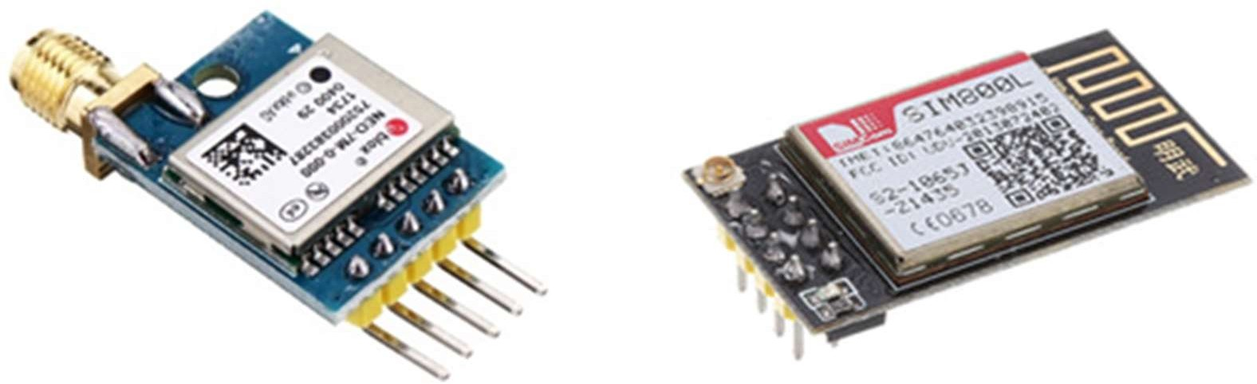

GPS Module GSM Module
Material: GPS (Navigation) (NEO-6M G(5V) or u-blox NEO-M8N(3.3V)) approximate size 4 cm x 4 cm x 1 cm.
GSM (Communication) (SIM800L or SIM900A) size around 3.5 cm x 3.5 cm x 1 cm.

Features:
GPS - Accurate Positioning and Tracking, Autonomous Functionality.
Enables real-time geo-location and movement monitoring for precise navigation and user interaction. Operates independently, providing essential data without user data transmission, enhancing navigation reliability.
GSM - Seamless Communication, SIM Card Integration.
Facilitates reliable wireless connectivity, supporting data rates from 64 kbps to 120 Mbps, enhancing the cart's responsiveness. Incorporates secure subscriber identity module (SIM) for cellular network access, enabling remote control and monitoring capabilities.

Safety Alerts:

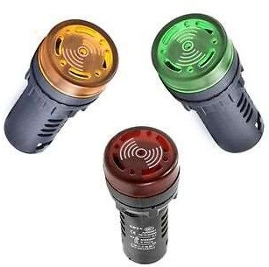
Material: Flash Alarm Indicator Signal Lamp With Buzzer 12/24/110/220V AD16-22SM LED
Features: The AD16-22SM LED Flash Alarm Indicator pairs a bright flashing LED lamp with an audible buzzer, offering dual alerts for attention-grabbing effectiveness. With voltage options ranging from 12V to 220V, it suits various applications. Its robust construction, easy mounting, and suitability for safety systems, machinery, and emergency notifications make it valuable across industries. The device ensures both visual and auditory alarms, enhancing effectiveness in various environments.

Battery and Power Management:

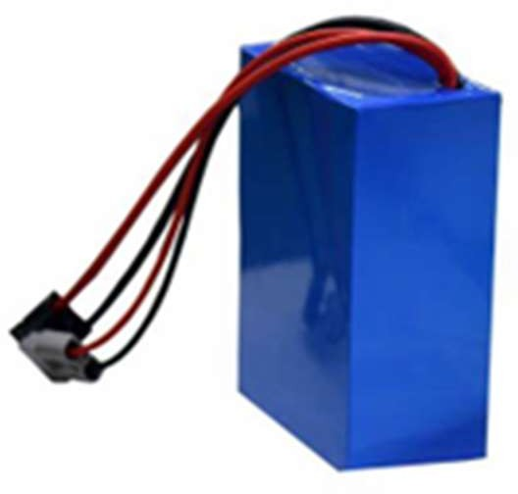

Material: Lithium Iron Phosphate (LiFePO4) Battery Cells, Electronic Components (PCB)
Features: LiFePO4 cells offer high energy density and safety. Smart power management system optimizes energy usage and provides user-friendly features like indicators and charging ports.

Mechanical Locking Mechanism:
Material: High-Strength Metal (Steel/Aluminum), Lock Mechanism (Metal/Plastic)
Features: High-strength metal components ensure secure locking, metal/plastic lock mechanism offers reliable and durable locking.

Luggage Compartment:
Material: Metal, Plastic
Features: By combining the strengths of metal and plastic materials, the luggage compartment offers a balance of durability, security, customization, and functionality, ensuring a reliable and user-friendly storage solution for traveler's belongings.

Materials and Aesthetics:
Material: Various colors and finishes for the chassis and frame
Features: stylish design with various color options in cart, metal or plastic accents enhance aesthetics.

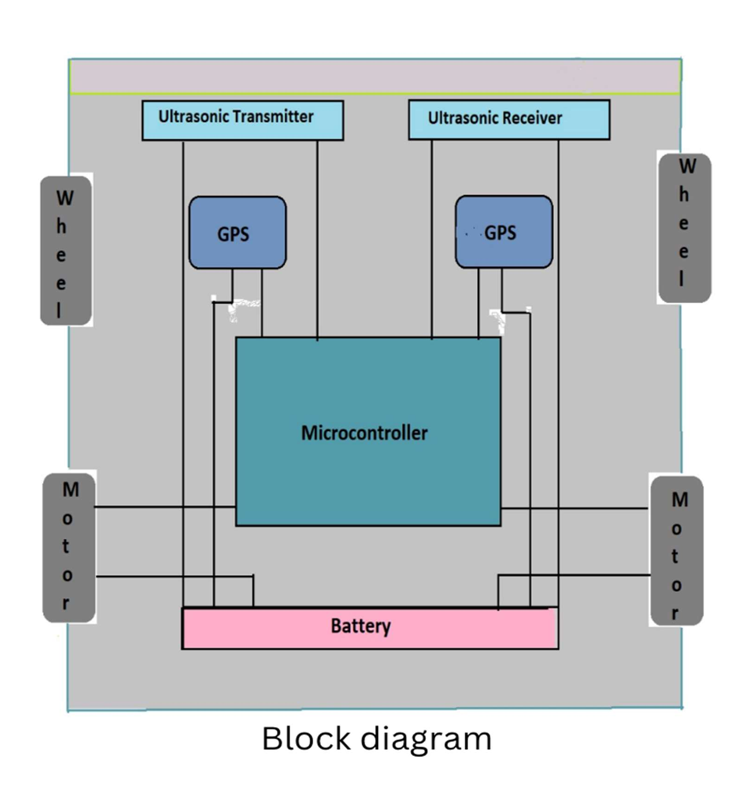
BLOCK DIAGRAM

PROCEDURE FLOW DIAGRAM

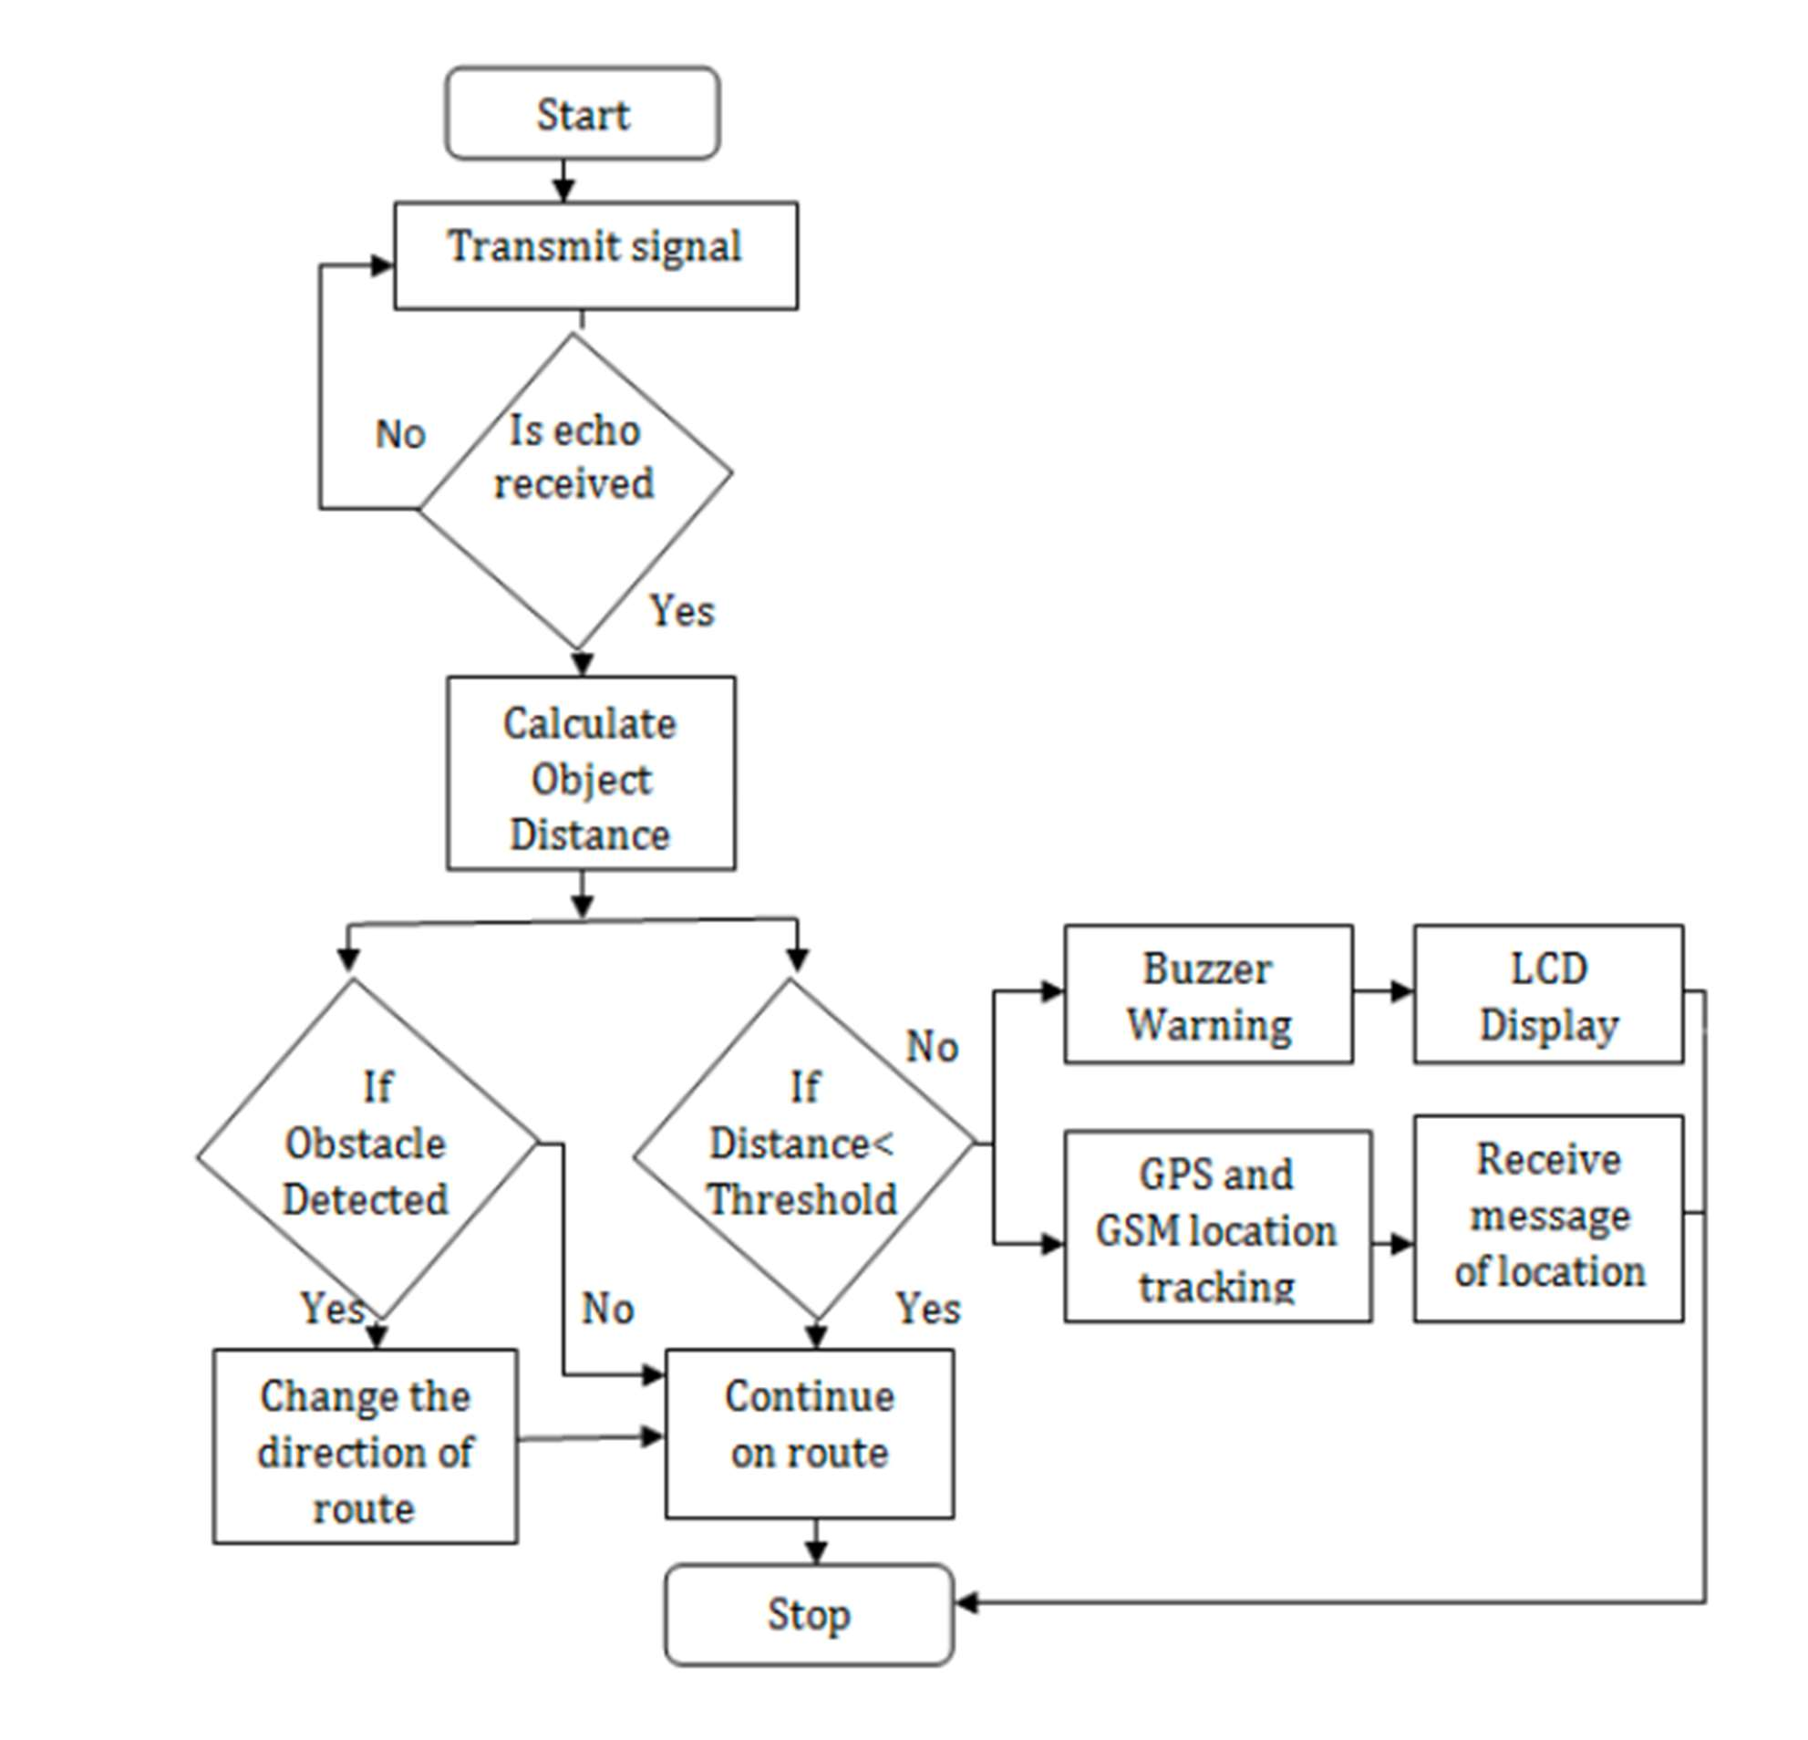
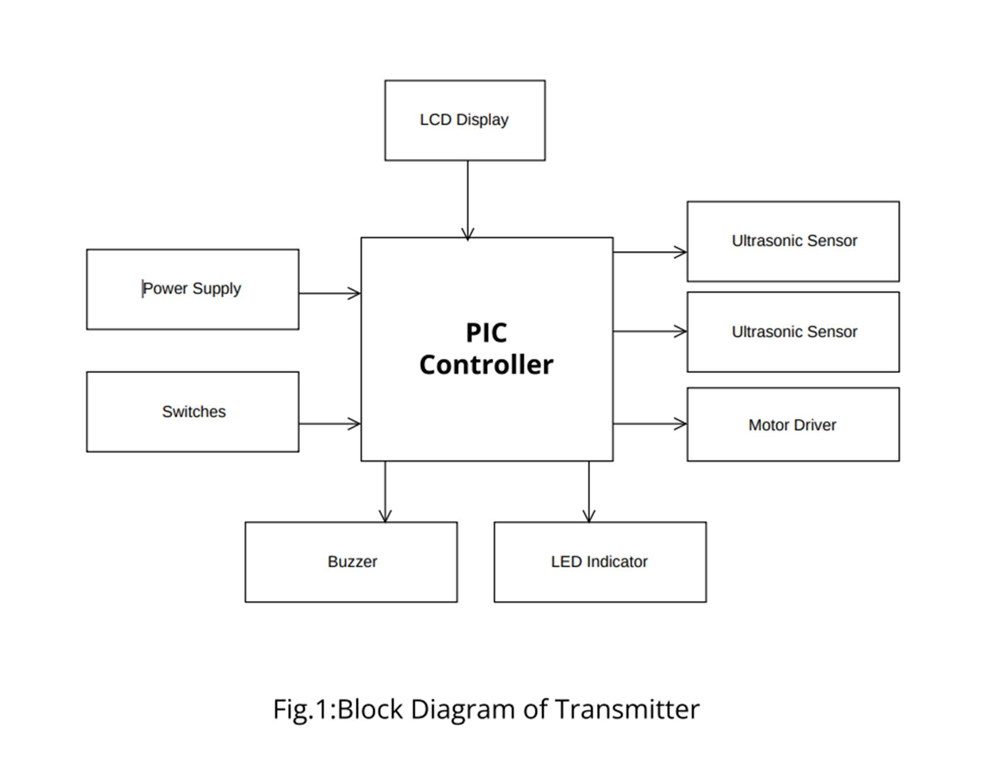
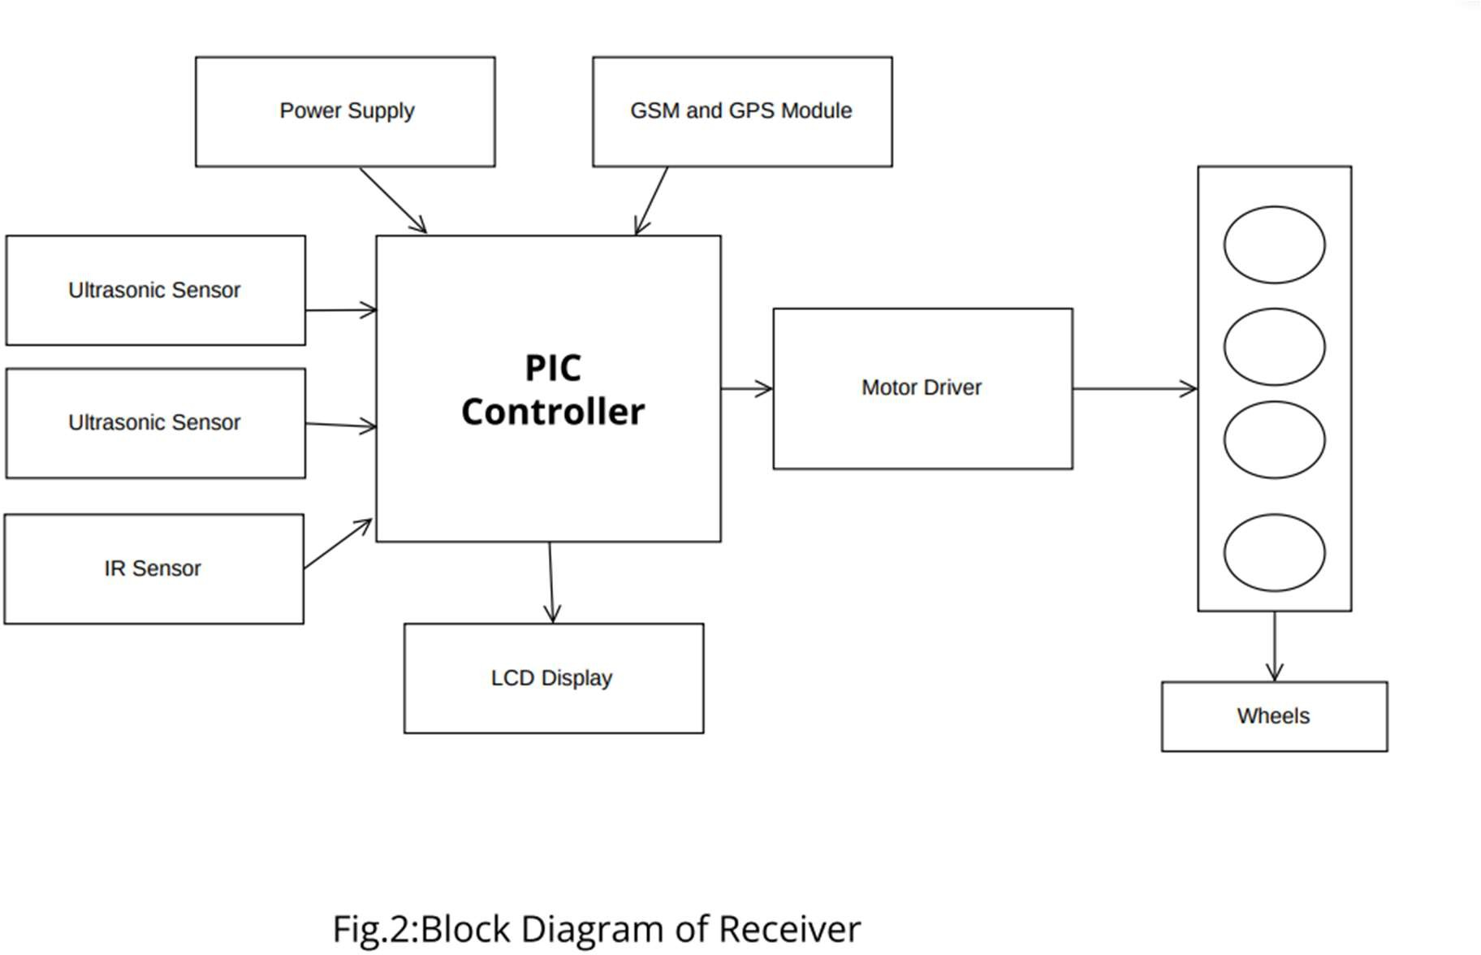

The system employs ultrasonic sensors for user tracking, a PIC microcontroller for control, and IR sensors for obstacle detection. GPS and GSM modules contribute anti-theft capabilities, while DC motors enable precise movement. The device aims to alleviate the burden of manually dragging heavy luggage and provides added security features.

CHAPTER 2: PRODUCT DEVELOPMENT AND MARKET

Product Development Process

A methodical approach to product development that includes multiple phases, from ideation to market launch, is required to create a hands-free trolley. This is a thorough, step-by-step procedure of how a hands-free trolley is developed:

1. Idea generation and conceptualization:

Market analysis: Find out what the market has to say about material handling and trolleys, as well as any gaps in the sector.

- Ideation and Brainstorming: - To generate original ideas for the hands-free trolley, put together a cross-functional group and conduct brainstorming sessions.

Idea Screening: Evaluate and sort created ideas based on their cost, market demand, viability, and compatibility with the company's goals.

Concept Development: - While keeping user experience, design, and functionality in mind, generate rough concepts for the hands-free trolley.

2. Analysis of the market and product specifications:

Market Segmentation: Identify the target customer segments by examining their demographics, inclinations, and needs in respect to the hands-free trolley.

Analyse your competitors' products, services, costs, and marketing strategies to identify areas in which you may differentiate yourself.

Product requirements: - Using the information gathered, thoroughly outline the features and specifications of the product, ensuring that they align with the market's demands and the state of technology at hand.

3. Design and Engineering:

- Detailed Design and Prototyping: - Construct thorough engineering requirements and intricate 3D designs while considering production processes, materials, and ergonomics.
. Make prototypes to verify functionality, design concepts, and user experience.

Iterative Testing and Refinement: Examine the functionality and design for usability, then gather feedback to make the necessary adjustments.

4. Scheduling of the Production Process:

Choosing suppliers and Purchasing Materials: - Locate and establish relationships with suppliers of the required materials, ensuring dependable, reasonably priced, and high-quality products.

Manufacturing Process Optimization: - Determine the best manufacturing practices for each component and the hands-free trolley assembly.

Establish quality control procedures to ensure that all stages of manufacturing adhere to predefined standards and requirements.

5. Production and Assembly:
Pilot Production: Test the manufacturing processes and increase productivity before starting large-scale production.

Manufacturing and Assembly: - To produce the hands-free trolleys, begin large-scale manufacturing by following the assembly instructions and process optimizations.

6. Testing and Quality Control:

Performance Testing: Conduct comprehensive performance tests, such as load capacity, durability, and functional testing, to ensure the trolley meets the requirements set forth.

Quality assurance: - Apply quality control tests at various manufacturing stages to ensure product consistency and quality.

7. Market introduction and distribution:

Marketing Strategy: - To introduce the hands-free trolley, develop a marketing and promotional plan that includes branding and offline and online marketing initiatives.

Distribution Network: Form partnerships with distributors, retailers, or e-commerce sites to expand your customer base and facilitate the trolley's delivery.

8. Assessment and Revision After Launch:

Customer Input: - Use the hands-free cart to collect user input and identify areas that could use improvement or addition.

Continuous Improvement: Based on feedback from customers and market performance statistics, the product must be continuously iterated to meet evolving customer wants and preferences.

Using this method to product development, you can create a hands-free trolley that satisfies consumer demands, provides an exceptional user experience, and gives you a competitive edge in the market.

Design for Manufacture

To guarantee effectiveness and user-friendliness, ergonomic, functional, and safety factors must be considered while designing a hands-free trolley for production. This is a detailed how-to for creating a hands-free manufacturing trolley:

Step 1: Identify the Conditions and Limitations
1. Load Capacity: Establish the utmost weight that the cart is required to support.

2. Size and Dimensions: Specify the measurements needed to fit different objects.

3. Mobility and Manoeuvrability: Take into account the kind of surface and available space where the trolley will be utilized.

4. Ergonomics: Make sure the trolley's layout minimizes user strain and provides simple access to things.

5. Durability and Materials: Choose materials that are long-lasting and resilient to the production environment.

Step 2: Conceptual Design
1. Frame Design: - Create a sturdy frame to maintain stability and support the weight.
- Make use of strong, lightweight materials like steel or aluminium.

2. Wheel System: - Include a set of wheels that are appropriate for the production setting (e.g., tough, lockable, and swivel).
- Assure the trolley moves easily and smoothly.

3. Handlebar and Controls: - Create an ergonomic, movable handlebar for effortless handling.
- Take into account ergonomic grips and speed or braking controls.

4. Loading space: - Construct a roomy and flexible loading space that can hold a range of goods and packages.
Make use of a non-slip surface to stop objects from slipping while being transported.

5. Integration of Hands-Free Mechanism: - To allow pushing or pulling the trolley without using your hands, incorporate an automatic locking mechanism or foot pedal.

Step 3: Engineering and Detailed Design
1. Wheel System Details: - Based on load capacity and terrain factors, specify the type, size, and material of the wheels.
- For stability and safety, incorporate a brake system.

2. Handlebar Details: - Include height adjustments to accommodate users of varying statures.
- Include cushioning and ergonomic grips for increased user comfort.

3. Integration of Hands-Free Mechanism: - Create a foot pedal mechanism that allows the trolley to be locked or unlocked without the need for hands.
Make sure it's simple to activate and disengage the mechanism.

4. Material Selection and Structural Details: - Choose the right materials for the frame, handlebar, and loading area based on their strength and suitable thickness.
- Where necessary, add reinforcement to improve durability.

5. Safety equipment: - Add extra safety by putting in place equipment like parking brakes, auditory warning signals, and reflective strips for visibility.

Step 4: Testing and Prototyping
1. Testing and Evaluation: - Test the trolley to make sure it satisfies the established requirements for load capacity, manoeuvrability, and safety.
- Get input from prospective users and adjust the design as needed.

Step 5: Manufacturing Finalization
1. Final Design Refinement: Using input from the prototype testing phase, make final design adjustments.

2. Selection of Manufacturing method: - Based on material choice and production volume, select a suitable manufacturing method (e.g., welding, casting, machining).

3. Production and Quality Control: - To ensure constant product quality, apply quality control procedures all the way through the production process.

4. Distribution and Packaging: - Create appropriate packaging to guarantee the trolleys are safeguarded both in storage and during transportation.
- Arrange for effective delivery and distribution to final consumers.

By using this methodical approach, it will be easier to build a hands-free trolley that is safe, useful, and functional for production.

Estimate of Manufacturing Cost

- Chassis and Frame: ₹3,700 per unit
- Handle and Frame: ₹1,800 per unit
- Wheels: ₹1,500 per unit
- Motors: ₹3,000 per unit
- Ultrasonic Sensors (5 units): ₹1,000 x 5 = ₹5,000
- IR Sensor (4 units): ₹2000 per unit
- Computer Vision Cameras: ₹1,800 per unit
- GPS Module: ₹1,500 per unit
- Safety Alert Buzzers: ₹150
- Battery: ₹3,000 per unit
- Connectivity: ₹800 per unit
- Locking Mechanism: ₹1,100 per unit
- Circuit Board and Electronics: ₹1,500 per unit
- Charging System: ₹800 per unit

TOTAL ESTIMATED MANUFACTURING COST=₹27,650(approximately ₹25,000 - ₹30,000)
Estimating labor, overhead, quality control, and potential design change costs can be complex and highly variable depending on factors such as location, labor rates, production volume, and specific project requirements. However, I can provide you with a general overview of how these costs might be estimated:
Labor Costs:
- Labor costs involve wages for skilled workers involved in various stages of production, assembly, testing, and quality control.
- The number of workers, their skill levels, and the time required for each task will impact labor costs.
- Depending on the complexity of the manufacturing process and the location of production, labor costs could range from 15% to 35% of the total manufacturing cost.
Overhead Costs:
- Overhead costs include facility expenses (rent, utilities), administrative expenses, equipment maintenance, and other indirect costs.
- Overhead costs are typically a percentage of the total manufacturing cost and can vary widely, ranging from 5% to 20% or more.
Quality Control Costs:
- Quality control costs cover testing, inspection, and ensuring the product meets safety and performance standards.
- Costs may include specialized equipment, trained quality control personnel, and compliance with regulatory standards.
- Quality control costs can vary based on the complexity of the product and industry requirements, ranging from 5% to 15% of the total manufacturing cost.
Potential Design Changes and Iterations:
- Design changes and iterations can lead to additional costs for engineering, prototyping, and testing.
- It's advisable to allocate a certain percentage of the total budget to account for potential design changes, ranging from 5% to 10%.

- Labor Costs = Total Estimated Manufacturing Cost × (Estimated Labor Percentage)
- Overhead Costs = Total Estimated Manufacturing Cost × (Estimated Overhead Percentage)
- Quality Control Costs = Total Estimated Manufacturing Cost × (Estimated Quality Control Percentage)
- Potential Design Change Costs = Total Estimated Manufacturing Cost × (Estimated Design Change Percentage)

For example, if you use a mid-range value of 25% for labor costs, 12.5% for overhead costs, 10% for quality control costs, and 7.5% for potential design change costs:

Labor Costs = ₹27,500 × 0.25 = ₹6,875
Overhead Costs = ₹27,500 × 0.125 = ₹3,437.5
Quality Control Costs = ₹27,500 × 0.1 = ₹2,750
Potential Design Change Costs = ₹27,500× 0.075 = ₹2,062.5

Total Additional Costs (Labor + Overhead + Quality Control + Design Changes) = ₹6,875+ ₹3,437.5 + ₹2,750+ ₹2,062.5 = ₹15,130

Adding this total to the previously calculated manufacturing cost range:

Total Estimated Cost (Including Additional Costs) = ₹27,500 + ₹15,130= ₹42,630

Please note that these are rough estimates, and the actual costs can vary significantly

ECONOMICS OF PRODUCT DEVELOPMENT PROJECTS

- Initial Investment:
Product development projects often require significant upfront investments in research and development, prototyping, and testing. These costs need to be weighed against the potential returns from successful product launch and sales.
- Market Demand and Viability:
Thorough market research helps assess the demand for the product and its viability in the target market. Understanding customer needs, preferences, and trends is crucial for making informed decisions.
- Return on Investment (ROI):
Calculating the potential ROI helps determine the financial attractiveness of the project. ROI is the ratio of the net profit generated by the product to the total investment made.
- Cost Management:
Effective cost management throughout the development process is essential. Balancing costs associated with materials, manufacturing, labour, and other factors is crucial to achieve profitability.
- Economies of Scale:
As production volume increases, per-unit costs tend to decrease due to bulk purchasing of materials and more efficient manufacturing processes. Higher sales volumes can lead to improved profitability.
- Time-to-Market:
Launching the product sooner can lead to earlier revenue generation and a competitive advantage. However, rushing the development process can lead to quality issues and increased costs.
- Risk Assessment and Mitigation:
Identifying potential risks and developing strategies to mitigate them is vital. Unforeseen challenges such as regulatory hurdles or unexpected design changes can impact project costs.
- Pricing Strategy:
Setting the right price point is critical. The price should reflect the product's value proposition and competitive positioning while covering development and production costs.
- Intellectual Property (IP) Protection:
Investing in IP protection through patents, trademarks, and copyrights can safeguard your innovations and potentially provide additional revenue through licensing.

- Lifecycle Costs:
Consider not only the upfront development and production costs but also ongoing expenses such as maintenance, customer support, updates, and potential recalls.
- Competitive Landscape:
Analyse competitors and their offerings to position your product effectively. Differentiating your product and offering unique value can impact pricing and demand.

- Sustainability and Environmental Factors:
Consumer preferences are shifting towards environmentally friendly products. Considering sustainability aspects in your product design and manufacturing can impact market appeal.
- Distribution and Marketing Costs:
Budgeting for distribution, marketing, and sales efforts is crucial for reaching target customers and driving sales.
- Flexibility and Adaptability:
The ability to adapt to changing market conditions and customer feedback is important. Continuous improvement and updates can extend the product's lifecycle.
Remember, successful product development projects involve a combination of thorough planning, efficient execution, and continuous assessment of economic factors to achieve both innovation and profitability.

CHAPTER 3: PRODUCT ECONOMIC FEASIBILITY

ECONOMIN ANALYSIS

STRATEGIES WITH TOOLS AND BUDGET:
The goal of an economic feasibility analysis is to determine the project's viability through a cost-benefit analysis of the proposed project. This phrase describes the objective and logical identification of a project's advantages, disadvantages, opportunities, and risks as well as the resources required to carry it out and its likelihood of success. It also describes the analysis and assessment of a project's capacity to assist in decision-making. It consists of economic, technical, and market analyses as well as strategies.
Based on the manufacturing cost estimates and the additional cost considerations, here's an economic analysis for the hands-free cart:
- Estimated Manufacturing Cost Breakdown:

Component | Quantity | Cost Range (₹)
Exterior Shell | 1 | ₹2,200 - ₹3,700
Handle Frame | 1 | ₹1,100 - ₹1,800
Wheels | 4 | ₹750 - ₹1,500
Motors | 2 | ₹1,500 - ₹3,000
Sensors | Varies | ₹750 - ₹1,500
Computer vision cameras | Varies | ₹1,100 - ₹1,800
GPS Module | 1 | ₹750 - ₹1,500
Battery | 1 | ₹1,900 - ₹3,000
Mobile app and connectivity | N/A | ₹400 - ₹800
Locking Mechanism | 1 | ₹750 - ₹1,100
Circuit Board and Electronics | 1 | ₹750 - ₹1,500
Charging System | 1 | ₹400 - ₹800
Interior Lining | 1 | ₹400 - ₹800
Total estimated Manufacturing cost for the Hand free cart |  | ₹25,000 - ₹30,000

Labor Costs (25%) | ₹6,875
Overhead Costs (12.5) | ₹3,437.5
Quality control Costs (10%) | ₹2,750
Potential Design Change Costs (7.5%) | ₹2,062.5
Total additional Costs | ₹15,130

- Additional Costs:
Market Considerations:
Research and analyse the potential market demand for a hands-free cart.
Identify target customers (businesses, individuals) and assess their willingness to pay for such a product.
Study competitors and pricing strategies in the market.
Revenue Projection:
Calculate potential revenue by estimating the number of units sold based on market research.
Multiply the estimated sales volume by the expected selling price.
Profitability Analysis:
Subtract the total estimated cost (including additional costs) from the projected revenue to calculate potential profit.
Assess whether the projected profit margin aligns with your business goals and industry standards.
Analyse how these variations could impact the overall profitability of the product.
Return on Investment (ROI):
Calculate the ROI by dividing the potential profit by the total investment (including development, manufacturing, and additional costs).
Evaluate whether the ROI meets your investment criteria.

FINANCIAL MODEL

Here's a basic outline of the financial model in spreadsheet form, outlining the key components and calculations:
Calculations:
- Calculate Additional Costs for Each Component:
Additional Cost = Component Cost × (Labor + Overhead + Quality Control + Design Changes)

- Calculate Total Additional Costs:
Total Additional Costs = Sum of Additional Costs for All Components
- Calculate Total Estimated Manufacturing Cost (Including Additional Costs):
Total Estimated Cost = Total Component Costs + Total Additional Costs.

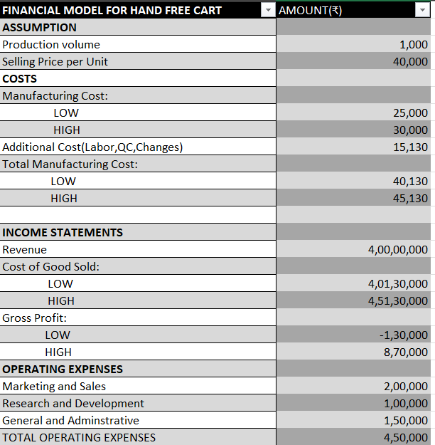
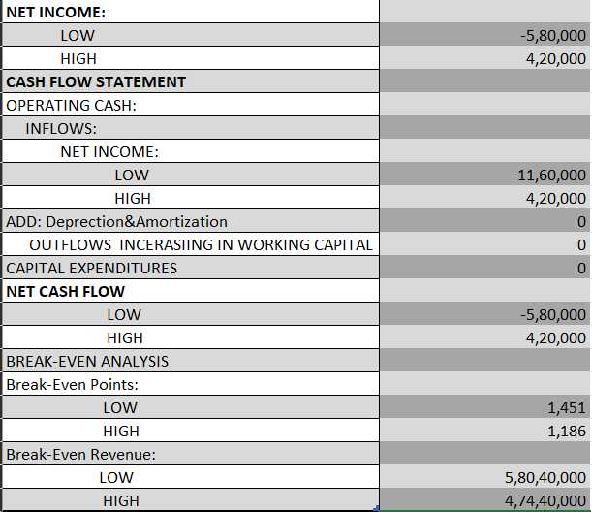

SENSITIVE ANALYSIS
1.Cost Sensitivity:
- Any decrease in manufacturing costs will have a significant impact on the hands-free cart's profitability. Optimizing production processes or procuring materials more effectively are two small but powerful ways to reduce costs and boost profit margins.
2.Market Expansion Sensitivity:
- The hands-free cart's potential for expansion depends on its ability to successfully penetrate markets outside its target audience of high-class consumers. Market constraints, such as sensitivity to shifts in customer preferences or economic downturns, might impact the market for luxury products like hands-free carts.

3. 3. Technical Failure Sensitivity:
- The reputation and user happiness of the hands-free cart are greatly influenced by the dependability of its technological components, such as Bluetooth, GPS, charging, camera, locking, and sensors (IR and Ultra Sonic). Any faults or technological problems could result in unhappy customers and higher support expenses.

4. Competition Sensitivity:
- Competitive Pressure Sensitivity: The product faces potential competition from existing products with similar features or from new entrants. Its market share and profitability are sensitive to how well it distinguishes itself from competitors and responds to market dynamics.
5. Economic Sensitivity:
- Situation in the Economy Sensitivity: The success of the hands-free cart depends on a number of economic factors, mainly the target market's disposable income. While economic upturns may increase sales, particularly among affluent consumers, economic downturns may decrease demand.
6. Supply Chain Sensitivity:
- Unexpected supply chain disruptions, like natural catastrophes or international crises, may have an influence on the availability of essential components and have an impact on production schedules. Controlling these risks is crucial to preserving a steady supply of products.
7. Innovation Sensitivity:
- Technological Progress Sensitivity: In an ever-evolving technology field, the hands-free cart needs to constantly develop in order to remain competitive. Long-term relevance can be ensured by being responsive to technological changes and having the capacity to integrate new features.
8. Price Sensitivity:
- Sensitivity to Price Changes: The hands-free cart's revenue and sales volume are susceptible to changes in pricing tactics. Pricing ought to be in line with the features, perceived value, and demand of the market for the product.
9. Consumer Perception Sensitivity:
- Sensitivity to Customer Feedback: Customer opinions and reviews have an impact on the hands-free cart's reputation and sales. In the era of social media and online reviews, negative comments can hurt sales while positive comments can boost them.
10. Distribution and Partner Relationship Sensitivity:
- The effectiveness and dependability of partnerships can have a significant impact on joint ventures with airlines, retailers, or distribution partners. Strong partner networks can increase sales and product visibility.

INFLUENCE OF THE QUANTITATIVE FACTORS

Let’s analyse how some of the quantitative factors can influence hands-free cart’s success:

1. Gross Profit:
- The gross profit per unit of the hands-free cart sold indicates the financial viability of the product. Higher gross profits contribute to the overall profitability of the venture.
- Gross profit margin is a quantitative metric that expresses the percentage of revenue retained as profit after accounting for manufacturing and operational costs.

2.Market Expansion Potential:
- Quantitative data regarding the market expansion potential of the hands-free cart is essential. This includes the number of potential customers within various market segments, such as elderly individuals, tech enthusiasts, and kids.
- Growth projections, quantified as a percentage increase in market share or sales volume, provide insights into the product’s potential revenue growth.

3.Technology Reliability:
  - Quantitative metrics related to technology reliability, such as the failure rate of components or system uptime, influence user satisfaction and operational costs.
  - The cost of technical support and maintenance, measured in terms of expenditures or as a percentage of revenue, directly affects profitability.

4.Price and Pricing Strategy:
  - The pricing of the hands-free cart, quantified as the selling price per unit, directly impacts sales volume and revenue generation.
  - Price elasticity of demand, a quantitative measure, helps determine how changes in pricing will affect the quantity sold.

5.Investment in Research and Development:
  - The quantitative factor of R&D investment in the hands-free cart’s development reflects the commitment to innovation. Higher investments may lead to new features or enhanced performance, potentially increasing market share and revenue.

6.Market Share and Competitive Metrics:
  - Quantitative data on the hands-free cart’s market share compared to competitors is essential for assessing the product’s success and competitive position.
  - Tracking changes in market share over time, expressed as percentages, provides insights into the product’s competitive influence on revenue.
7.Return on Investment (ROI):
- ROI is a critical quantitative metric that assesses the financial performance of the hands-free cart. It quantifies the relationship between the initial investment in product development and the profit generated over time

CHAPTER 4: ENTREPRENEURIAL COMPETENCE
SWOT ANALYSIS

Strengths:
- Hands-Free Operation: The Hands-Free Cart's main advantage is its self-sufficient operation, which enables users to move their bags without exerting themselves physically.
- Clever Features: The cart's operation and user experience are improved by the incorporation of GPS tracking, avoiding obstacles, and anti-theft mechanisms.
- User-Friendly: A wide range of users, which includes older people, the disabled, and travellers, can utilize the product because of its emphasis on user-friendliness, which includes simple access and control.
- Innovative Design: As seen in Concept 4, the special fusion of current technologies and ideas provides a commercial advantage.

Weaknesses:
- Complex Technology: Using cutting-edge technologies like GPS, GSM, and obstacle-avoidance systems can be complicated and possibly cause technical problems.
- Maintenance Requirements: Some users may find it disadvantageous, but autonomous systems need to be updated and maintained on a regular basis to guarantee seamless operation.
- Cost: Compared to conventional carts, the creation and production of such a complicated product may be more expensive.
- Restricted Adaptability: Some people may not be comfortable using wrist watches or other smart features therefore they may not be able to fully utilize them.

Opportunities:
- Market Growth: There is a large market opportunity due to the growing need for creative, user-friendly luggage transit solutions in public areas.
- Wide Range of Users: The Hands-Free Cart is suitable for a variety of users, such as parents with small children, travellers, the elderly, and those with disabilities.
- Customization: By providing choices for design, colour, and other features, you may draw in a wider range of clients.
- Sustainability: The increasing trend toward sustainability in product design is in line with the emphasis on eco-friendly materials and energy-efficient components.

Threats:
- Technological Challenges: In order to remain competitive and safe from emerging dangers, technology may need to update frequently due to its rapid developments.
- Security Risks: Data security and privacy may be an issue because the device uses GPS and GSM technology.
- Regulatory Compliance: It can be difficult to meet the safety and regulatory requirements for products in public areas, and doing so may provide hazards to the law and compliance.

ENTERPRISE RESOURCE PLANNING (ERP)

Enterprise Resource Planning (ERP) can play a crucial role in the management and operations of the Hands-Free Cart project.

- Supply chain management: ERP systems can help manage the procurement and supply chain process for the Hands-Free Cart project. It can track inventory levels, manage orders, streamline purchasing processes, and ensure timely delivery of components and materials required for cart production.

2. Project planning and resource allocation: ERP systems can assist in planning and scheduling resources for the project. It can allocate human resources, equipment, and materials efficiently, ensuring smooth project execution and timely completion.

3. Financial Management: ERP systems can handle financial aspects such as budgeting, cost tracking, and financial reporting for the Hands-Free Cart project. It can generate reports on project expenses, track financial transactions, and provide insights into project profitability.

4. Quality Control: ERP systems can incorporate quality control modules to monitor and track the quality of components and the finished Hands-Free Carts. It can enforce quality control measures, track defects, and ensure compliance with industry standards and regulations.

5. Collaboration and communication: ERP systems often include features for collaboration and communication among project teams. This can facilitate seamless communication, document sharing, and real-time updates, enabling better coordination and teamwork throughout the project lifecycle.

6. Analytics and performance measurement: ERP systems can provide data analytics and reporting capabilities to measure project performance. Key performance indicators, such as production efficiency, cost variance, and delivery timelines, can be monitored and analysed to identify areas for improvement and optimize project outcomes.

7. Customer relationship management (crm): ERP systems with CRM functionalities can help manage customer interactions and enhance customer satisfaction. It can track customer requirements, handle inquiries and complaints, and support post-sales activities, ensuring a positive customer experience.
By implementing a comprehensive ERP system tailored to the needs of the Hands-Free Cart project, organizations can streamline operations, improve efficiency, and achieve better overall project management.

SUPPLY CHAIN MANAGEMENT

Supply chain control plays important role inside the improvement and implementation of hands-free carts. It involves the coordination and optimization of various approaches, from sourcing raw materials to turning in the completed carts to cease-customers. here are some key aspects of supply chain control in the context of Hands-Free carts:

1. Sourcing: - Step one is to discover dependable providers for the components and materials had to manufacture the hands-free carts. This consists of electronic additives, sensors, navigation structures, batteries, chassis, wheels, and other essential parts. making sure nice and fee-effectiveness is important.

2. Production: -Once the essential additives are sourced, the hands-free carts are manufactured, assembled, and examined. green manufacturing strategies and fine manipulate measures must be in location to satisfy the demand and keep consistency in the production manner.

3.Distribution: -After manufacturing, the hands-free carts want to be dispensed to the intended markets or clients. This involves coping with logistics and transportation to make certain well-timed delivery. selecting the proper distribution channels and optimizing the transport routes can help streamline the technique.

4. Inventory control: -Powerful inventory control is crucial to meet demand and keep away from stock outs or excess inventory. preserving finest inventory tiers calls for accurate demand forecasting and tracking of income developments. implementing inventory management structures can assist automate and streamline this procedure.

5. After-sales aid: -Deliver chain control also includes providing after-sales support, together with coping with maintenance, replacements, and consumer inquiries. setting up a responsive customer support machine and coping with spare element availability is crucial to ensure customer satisfaction.

6. Collaboration with companions: - Collaborating with companions, inclusive of suppliers, logistics companies, and stores, is crucial for a clean supply chain. constructing sturdy relationships and effective conversation channels with partners can assist improve performance and deal with any demanding situations which can stand up.
7. Non-stop improvement: - Often reviewing and optimizing the supply chain approaches is vital to perceive regions for development. this can involve leveraging era, enforcing automation, reducing fees, and improving ordinary performance.
By means of correctly dealing with the supply chain, hands-free cart manufacturers can make sure unbroken waft of merchandise from production to cease-users, meeting customer needs successfully and preserving an aggressive part in the market.

CONCEPT OF ENTREPRENEURSHIP

- Identification of Opportunity: The need for a more easily accessible and user-friendly luggage transportation option in public areas presents an opportunity for our project. The first stage in your entrepreneurial journey is to identify this opportunity.

- Innovative Idea: Our idea is to create a "Hands-Free Cart" that combines pre-existing concepts and technologies to provide a fresh approach to the problem that has been addressed.

- Market research: With regard to our project, this entails learning about the requirements and inclinations of our intended audience. To find out about user demographics, market demand, and competition in the hands-free cart space, we would carry out research and surveys.

- Business Plan: Our business plan covers every aspect of the project, including the target market (elderly, disabled, travellers, etc.), pricing strategy, marketing strategy, and financial predictions. It also includes the product concept (Hands-Free Cart). This plan is our road map to product development and launch.

- Resource Acquisition: We would obtain the required resources, including capital for R&D, supplies for building carts, and expertise for creating, producing, and promoting the hands-free cart.

- Risk Management: This part of our project would entail spotting possible obstacles like technical problems, rivalry, or problems with market acceptance. We would create plans to lessen these dangers.

- Product Development: As entrepreneurs, we develop our products manually to ensure that they meet the needs of the market and become successful. This stage includes the creation and design of the product.

- Prototyping and testing: Build a hands-free stroller model to test functionality and gather user feedback prior to mass production. Iterative testing ensures that the final product is usable and useful.

- Marketing and Advertising: Effective marketing and advertising strategies are used to reach the target customers. This includes looking at the unique features of hands-free walkers, such as GPS tracking, customer care, and anti-theft devices.

- Scaling and Growth: Once your product is created and developed, you can control its scale and growth opportunities. This may include entering new markets, increasing production capacity, or launching different products.

- Adapt and improve: Marketing involves adapting marketing strategies and adapting them to meet customerneeds. Staying competitive requires continuous evaluation and adaptation.

- Sustainability and profitability: -In the pursuit of profit, it is important to consider sustainability in terms of eco-friendly materials and efficient energy use when producing hands-free strollers.

CONCLUSION

The "Hands-Free Cart" project aims to address accessibility challenges faced by individuals in using traditional carts for luggage transportation in public spaces. The device's functionality is underscored by its ability to emit and receive ultrasonic waves, intelligently navigate around obstacles, and securely communicate location data via GPS and GSM technologies. Customer requirements include ease of access, travel efficiency, affordability, control, ample storage, market readiness, heavy lifting capability, and smooth operation. The project involves concept generation through techniques like SCAMPER and TRIZ, resulting in the selection of good concept through a benchmarking matrix evaluation. In the future, the cart's design intends to enhance travel experiences by offering a convenient and secure solution for hands-free luggage transport.

BIBILIOGRAPHY

- Design and Implementing Automatic follower bag by Krishn Kumar Yadav, Nitesh Tiwari and Abhishek Yadav
- AUTOMATIC LUGGAGE FOLLOWER by Sonali Patil, Shrutika Patil, Anuja Patil, Prof. Deshmukh S. C.
- Nitin, Shyam. 2015. "SMS Based Kids Tracking and Safety System by Using RFID and GSM". IJISET -International Journal of Innovative Science, Engineering & Technology (Volume 2 Tahun 2015). ISSN: 2348 -7968. Diakses 15 September 2018. - RFID
- https://www.hackster.io/ruchir1674/how-to-interface-gps-module-neo-6m-with-arduino-8f90ad - Arduino with gps module
- https://www.academia.edu/42661755/A_Project_Based_Lab_Report_On_SMART_BLIND_STICK_USING_AURDINO_SUBMITTED_BY%20-%20arduino
- Electronic Luggage Follower César Nuñez, Alberto García, Raimundo Onetto, Daniel Alonzo, Sabri Tosunoglu Department of Mechanical Engineering Florida International University 10555 West Flagler Street Miami, Florida 33174 Florida Conference on Recent Advances in Robotics, FCRAR 2010 - Jacksonville, Florida, May 20-21, 2010.
- IEEE International Conference on Control System, Computing and Engineering, 27 - 29 November 2015, Penang, Malaysia. Visual Based Sensor Cart Follower for Wheelchair by using Microcontroller.
- https://www.indiatimes.com/technology/news/introducing-the-world-s-first-hands-free-suitcase-that-will-walk-with-you-wherever-you-go-263746.html - website detailing about tech in hands free suitcase
- https://youtu.be/_8_0iQRAtlM?si=oDZzlEOWhR_mN5KH – video representation of handsfree suitcase working model
- https://www.forbes.com/sites/grantmartin/2018/ 01/18/airline-smart-luggage-ban-goes-into- effect/#674f4166b648.
- J. David, N. Cheeke, Fundamentals of ultrasonic waves, Florida, USA: CRC Press, 2002, ISBN 0-8493- 0130-0.
- Chuan-Hao Yang” A person-tracking mobile robot using an ultrasonic positioning system” Naval postgraduate school Montery, CA 93943- 5000, December 2005.

